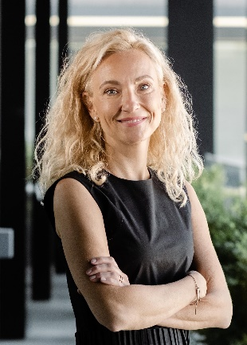
Kateřina Surková
Counsel
Kateřina Surková specialises in corporate law, company restructuring, creation of holding structures, and acquisitions and divestitures of companies.

In the field of commercial law, Kateřina focuses mainly on the law of commercial corporations, all types of company transformations, such as mergers and divisions of companies, both national and those with a foreign element. She also has extensive experience in creating Czech and foreign holding structures or setting up and settling relations between shareholders.

In the field of acquisitions and divestitures, Kateřina has been involved in several major real estate transactions both on the side of sellers and buyers in recent years.

Kateřina joined our law firm in 2007 and worked here as a junior associate and then as an associate. She also served as an attorney at PwC Legal, and in 2018 she returned to our law firm as a senior associate.

Projects

- comprehensive legal advice on the restructuring of a major construction group in the Czech Republic
- legal advice on the intra-group merger of a banking institution active in the Czech Republic and abroad
- transformation of major Czech companies operating in the automotive industry
- private advice to major Czech private clients, including the creation of fund structures with an international element
- comprehensive legal advice on corporate law to major Czech companies, subsidiaries of foreign investors active, inter alia, in the fields of construction, engineering or the chemical industry
- legal advice in connection with amendments to founding documents and statutes of companies in connection with their adaptation to the new private law
- legal advice on conducting legal due diligence related to the acquisition of leading companies active in the development, construction, engineering, food or automobile sectors
- legal advice in negotiating the acquisition of a major office building in Prague
- legal advice on a real estate acquisition in the North Moravian Region
- legal advice on the sale of a development project in Prague

Membership in Professional Associations

Czech Bar Association

Languages

Czech, English

Education

Masaryk University, Faculty of Law, Brno (2007), Mgr. (Master of Law)
University of Technology in Sydney, Sydney (2010), LL.M.

E: katerina.surkova@havelpartners.cz

